Joke about purim shpiel
12th grade

Daniel 7 25- (1st year of Belshazzar – Vision on the big picture)
וּמִלִּין לְצַד עִלָּאָה יְמַלִּל וּלְקַדִּישֵׁי עֶלְיוֹנִין יְבַלֵּא וְיִסְבַּר לְהַשְׁנָיָה זִמְנִין וְדָת וְיִתְיַהֲבוּן בִּידֵהּ עַד־עִדָּן וְעִדָּנִין וּפְלַג עִדָּן׃ וְדִינָא יִתִּב וְשׇׁלְטָנֵהּ יְהַעְדּוֹן לְהַשְׁמָדָה וּלְהוֹבָדָה עַד־סוֹפָא׃
He will speak words against the Most High, and will harass the holy ones of the Most High. He will think of changing times and laws, and they will be delivered into his power for a time, times, and half a time. Then the court will sit and his dominion will be taken away, to be destroyed and abolished for all time.
Daniel 8 14 – (3rd year of Belshazzar – Vision primarily on the Greek exile)
וָאֶשְׁמְעָה אֶחָד־קָדוֹשׁ מְדַבֵּר וַיֹּאמֶר אֶחָד קָדוֹשׁ לַפַּלְמוֹנִי הַמְדַבֵּר עַד־מָתַי הֶחָזוֹן הַתָּמִיד וְהַפֶּשַׁע שֹׁמֵם תֵּת וְקֹדֶשׁ וְצָבָא מִרְמָס׃ וַיֹּאמֶר אֵלַי עַד עֶרֶב בֹּקֶר אַלְפַּיִם וּשְׁלֹשׁ מֵאוֹת וְנִצְדַּק קֹדֶשׁ׃
Then I heard a holy being speaking, and another holy being said to whoever it was who was speaking, “How long will [what was seen in] the vision last the regular offering be forsaken because of transgression; the sanctuary be surrendered and the [heavenly] host be trampled?” He answered me, “For evening and morning - twenty-three hundred; then the sanctuary shall be cleansed.” … What was said in the vision about evenings and mornings is true. Now you keep the vision a secret, for it pertains to far-off days.”

Daniel 9 25 – (1st year of Darius the Mede - Vision on the current exile)
בִּתְחִלַּת תַּחֲנוּנֶיךָ יָצָא דָבָר וַאֲנִי בָּאתִי לְהַגִּיד כִּי חֲמוּדוֹת אָתָּה וּבִין בַּדָּבָר וְהָבֵן בַּמַּרְאֶה׃ שָׁבֻעִים שִׁבְעִים נֶחְתַּךְ עַל־עַמְּךָ וְעַל־עִיר קׇדְשֶׁךָ לְכַלֵּא הַפֶּשַׁע וּלְהָתֵם חַטָּאת וּלְכַפֵּר עָוֺן וּלְהָבִיא צֶדֶק עֹלָמִים וְלַחְתֹּם חָזוֹן וְנָבִיא וְלִמְשֹׁחַ קֹדֶשׁ קׇדָשִׁים׃ וְתֵדַע וְתַשְׂכֵּל מִן־מֹצָא דָבָר לְהָשִׁיב וְלִבְנוֹת יְרוּשָׁלַ͏ִם עַד־מָשִׁיחַ נָגִיד שָׁבֻעִים שִׁבְעָה וְשָׁבֻעִים שִׁשִּׁים וּשְׁנַיִם תָּשׁוּב וְנִבְנְתָה רְחוֹב וְחָרוּץ וּבְצוֹק הָעִתִּים׃ וְאַחֲרֵי הַשָּׁבֻעִים שִׁשִּׁים וּשְׁנַיִם יִכָּרֵת מָשִׁיחַ וְאֵין לוֹ וְהָעִיר וְהַקֹּדֶשׁ יַשְׁחִית עַם נָגִיד הַבָּא וְקִצּוֹ בַשֶּׁטֶף וְעַד קֵץ מִלְחָמָה נֶחֱרֶצֶת שֹׁמֵמוֹת׃ וְהִגְבִּיר בְּרִית לָרַבִּים שָׁבוּעַ אֶחָד וַחֲצִי הַשָּׁבוּעַ יַשְׁבִּית זֶבַח וּמִנְחָה וְעַל כְּנַף שִׁקּוּצִים מְשֹׁמֵם וְעַד־כָּלָה וְנֶחֱרָצָה תִּתַּךְ עַל־שֹׁמֵם׃
At the beginning of thy supplications the commandment went out, and I am come to declare it; for thou art greatly beloved: therefore look into the word, and consider the vision. Seventy weeks are decreed concerning thy people and concerning thy holy city, to finish the transgression, and to make an end to sins, and to atone for iniquity, and to bring in everlasting righteousness, and to seal up vision and prophet, and to anoint the most holy place. Know therefore and understand, that from the going forth of the commandment to restore and to build Yerushalayim until an anointed prince, shall be seven weeks: then for sixty two weeks it shall be built again, with squares and moat, but in a troubled time. And after sixty two weeks shall an anointed one be cut off, and none will be left to him: and the people of a prince that shall come shall destroy the city and the sanctuary; and his end shall be with a flood, and to the end of the war desolations are decreed. And he shall make a strong covenant with many for one week: and during half of the week he shall cause the sacrifice and the offering to cease; and upon the wing of abominations shall come one who makes desolate, until the decreed destruction is poured out on the desolator.

Daniel 12 – (3rd year of Cyrus – Details of the final exile (Rambam and Ibn Yechia)
וָאֶשְׁמַע אֶת־הָאִישׁ לְבוּשׁ הַבַּדִּים אֲשֶׁר מִמַּעַל לְמֵימֵי הַיְאֹר וַיָּרֶם יְמִינוֹ וּשְׂמֹאלוֹ אֶל־הַשָּׁמַיִם וַיִּשָּׁבַע בְּחֵי הָעוֹלָם כִּי לְמוֹעֵד מוֹעֲדִים וָחֵצִי וּכְכַלּוֹת נַפֵּץ יַד־עַם־קֹדֶשׁ תִּכְלֶינָה כׇל־אֵלֶּה׃ ... וּּמֵעֵת הוּסַר הַתָּמִיד וְלָתֵת שִׁקּוּץ שֹׁמֵם יָמִים אֶלֶף מָאתַיִם וְתִשְׁעִים׃ אַשְׁרֵי הַמְחַכֶּה וְיַגִּיעַ לְיָמִים אֶלֶף שְׁלֹשׁ מֵאוֹת שְׁלֹשִׁים וַחֲמִשָּׁה׃
Then I heard the man dressed in linen, who was above the water of the river, swear by the Ever-Living One as he lifted his right hand and his left hand to heaven: “For a time, times, and half a time;-a and when the breaking of the power of the holy people comes to an end, then shall all these things be fulfilled.” … From the time the regular offering is abolished, and an appalling abomination is set up—it will be a thousand two hundred and ninety days. Happy the one who waits and reaches one thousand three hundred and thirty-five days.

The Real Time
וְהָיָה כִי־יָבֹאוּ עָלֶיךָ כׇּל־הַדְּבָרִים הָאֵלֶּה הַבְּרָכָה וְהַקְּלָלָה אֲשֶׁר נָתַתִּי לְפָנֶיךָ וַהֲשֵׁבֹתָ אֶל־לְבָבֶךָ בְּכׇל־הַגּוֹיִם אֲשֶׁר הִדִּיחֲךָ ה' אֱלֹקֶיךָ שָׁמָּה׃ וְשַׁבְתָּ עַד ה' אֱלֹקֶיךָ וְשָׁמַעְתָּ בְקֹלוֹ כְּכֹל אֲשֶׁר־אָנֹכִי מְצַוְּךָ הַיּוֹם אַתָּה וּבָנֶיךָ בְּכׇל־לְבָבְךָ וּבְכׇל־נַפְשֶׁךָ׃ וְשָׁב ה' אֱלֹקֶיךָ אֶת־שְׁבוּתְךָ וְרִחֲמֶךָ וְשָׁב וְקִבֶּצְךָ מִכׇּל־הָעַמִּים אֲשֶׁר הֱפִיצְךָ ה' אֱלֹקֶיךָ שָׁמָּה׃ אִם־יִהְיֶה נִדַּחֲךָ בִּקְצֵה הַשָּׁמָיִם מִשָּׁם יְקַבֶּצְךָ ה' אֱלֹקֶיךָ וּמִשָּׁם יִקָּחֶךָ׃ וֶהֱבִיאֲךָ יְהֹוָה אֱלֹהֶיךָ אֶל־הָאָרֶץ אֲשֶׁר־יָרְשׁוּ אֲבֹתֶיךָ וִירִשְׁתָּהּ וְהֵיטִבְךָ וְהִרְבְּךָ מֵאֲבֹתֶיךָ׃ ...
When all these things befall you—the blessing and the curse that I have set before you—and you take them to heart amidst the various nations to which the Lord your God has banished you, and you return to the Lord your God, and you and your children heed His command with all your heart and soul, just as I enjoin upon you this day, then the Lord your God will restore your fortunes and take you back in love. He will bring you together again from all the peoples where the Lord your God has scattered you. Even if your outcasts are at the ends of the world, from there the Lord your God will gather you, from there He will fetch you. And the Lord your God will bring you to the land that your fathers possessed, and you shall possess it; and He will make you more prosperous and more numerous than your fathers.

Sanhedrin 97b
תניא רבי נתן אומר מקרא זה נוקב ויורד עד תהום (חבקוק ב, ג) כי עוד חזון למועד ויפח לקץ ולא יכזב אם יתמהמה חכה לו כי בא יבא לא יאחר לא כרבותינו שהיו דורשין (דניאל ז, כה) עד עידן עידנין ופלג עידן ולא כר' שמלאי שהיה דורש (תהלים פ, ו) האכלתם לחם דמעה ותשקמו בדמעות שליש ולא כרבי עקיבא שהיה דורש (חגי ב, ו) עוד אחת מעט היא ואני מרעיש את השמים ואת הארץ מאי ויפח לקץ ולא יכזב א"ר שמואל בר נחמני אמר ר' יונתן תיפח עצמן של מחשבי קיצין שהיו אומרים כיון שהגיע את הקץ ולא בא שוב אינו בא אלא חכה לו שנאמר אם יתמהמה חכה לו שמא תאמר אנו מחכין והוא אינו מחכה ת"ל (ישעיהו ל, יח) לכן יחכה ה' לחננכם ולכן ירום לרחמכם
It is taught Rabbi Natan says: This verse penetrates and descends until the depths; just as the depths are unfathomable, so too, the period depicted in the following verse is unquantifiable. “For the vision is yet for the appointed time; and it declares of the end, and does not lie; though it tarry, wait for it, because it will surely come; it will not delay” (Habakkuk 2:3).
(Maharsha, Ben Yehoyada)
Not in accordance with the opinion of our Rabbis, who would interpret the verse: “For a period and periods and a half period” (Daniel 7:25), [to mean that the duration of the ultimate exile will be three and a half times the duration of the period of the exile in Egypt.]
And not in accordance with the opinion of Rabbi Simlai, who would interpret the verse: “You have fed them with the bread of tears and have given them tears to drink in great measure [shalish]” (Psalms 80:6), [to mean that the duration of the ultimate exile will be three times the duration of the period of the exile in Egypt and Babylon]
And not in accordance with the opinion of Rabbi Akiva, who would interpret the verse: “Yet once, it is a little while, and I will shake the heavens and the earth” (Haggai 2:6), [to mean that the redemption would transpire soon after the destruction of the Temple.]
“And it declares [veyafe’aḥ] of the end, and does not lie”? Rabbi Shmuel bar Naḥmani says that Rabbi Yonatan says: May those who calculate the end of days be cursed [tippaḥ], as they would say once the end of days that they calculated arrived and the Messiah did not come, that he will no longer come at all. Rather, the proper behavior is to continue to wait for his coming, as it is stated: “Though it tarry, wait for it.” Lest you say we are expectantly awaiting the end of days and the Holy One, Blessed be He, is not awaiting the end of days and does not want to redeem His people, the verse states: “And therefore will the Lord wait, to be gracious to you; and therefore will He be exalted, to have mercy upon you; for the Lord is a God of judgment; happy are all they who wait for Him” (Isaiah 30:18).

Chabakuk 2
עַל־מִשְׁמַרְתִּי אֶעֱמֹדָה וְאֶתְיַצְּבָה עַל־מָצוֹר וַאֲצַפֶּה לִרְאוֹת מַה־יְדַבֶּר־בִּי וּמָה אָשִׁיב עַל־תּוֹכַחְתִּי׃ וַיַּעֲנֵנִי ה' וַיֹּאמֶר כְּתֹב חָזוֹן וּבָאֵר עַל־הַלֻּחוֹת לְמַעַן יָרוּץ קוֹרֵא בוֹ׃ כִּי עוֹד חָזוֹן לַמּוֹעֵד וְיָפֵחַ לַקֵּץ וְלֹא יְכַזֵּב אִם־יִתְמַהְמָהּ חַכֵּה־לוֹ כִּי־בֹא יָבֹא לֹא יְאַחֵר׃ הִנֵּה עֻפְּלָה לֹא־יָשְׁרָה נַפְשׁוֹ בּוֹ וְצַדִּיק בֶּאֱמוּנָתוֹ יִחְיֶה׃
I will stand upon my watch, and set me upon the tower, and will watch to see what he will say to me, and what I shall answer when I am reproved. And the Lord answered me, and said, Write the vision, and make it plain upon tablets, that he who reads it may run. For there is still a vision for the appointed time; and it speaks concerning the end, and does not lie: though it tarry, wait for it; because it will surely come, it will not delay. … but the rightous shall live by his faith.

Rambam Hilchos Milachim 12
... וְשֶׁקֹּדֶם מִלְחֶמֶת גּוֹג וּמָגוֹג יַעֲמֹד נָבִיא לְיַשֵּׁר יִשְׂרָאֵל וּלְהָכִין לִבָּם. שֶׁנֶּאֱמַר (מלאכי ג, כג) "הִנֵּה אָנֹכִי שׁלֵחַ לָכֶם אֵת אֵלִיָּה" וְגוֹ'. וְאֵינוֹ בָּא לֹא לְטַמֵּא הַטָּהוֹר. וְלֹא לְטַהֵר הַטָּמֵא. וְלֹא לִפְסל אֲנָשִׁים שֶׁהֵם בְּחֶזְקַת כַּשְׁרוּת. וְלֹא לְהַכְשִׁיר מִי שֶׁהֻחְזְקוּ פְּסוּלִין. אֶלָּא לָשׂוּם שָׁלוֹם בָּעוֹלָם. שֶׁנֶּאֱמַר (מלאכי ג, כד) "וְהֵשִׁיב לֵב אָבוֹת עַל בָּנִים". וְיֵשׁ מִן הַחֲכָמִים שֶׁאוֹמְרִים שֶׁקֹּדֶם בִּיאַת הַמָּשִׁיחַ יָבוֹא אֵלִיָּהוּ. וְכָל אֵלּוּ הַדְּבָרִים וְכַיּוֹצֵא בָּהֶן לֹא יֵדַע אָדָם אֵיךְ יִהְיוּ עַד שֶׁיִּהְיוּ. שֶׁדְּבָרִים סְתוּמִין הֵן אֵצֶל הַנְּבִיאִים. גַּם הַחֲכָמִים אֵין לָהֶם קַבָּלָה בִּדְבָרִים אֵלּוּ. אֶלָּא לְפִי הֶכְרֵעַ הַפְּסוּקִים. וּלְפִיכָךְ יֵשׁ לָהֶם מַחְלֹקֶת בִּדְבָרִים אֵלּוּ. וְעַל כָּל פָּנִים אֵין סִדּוּר הֲוָיַת דְּבָרִים אֵלּוּ וְלֹא דִּקְדּוּקֵיהֶן עִקָּר בַּדָּת. וּלְעוֹלָם לֹא יִתְעַסֵּק אָדָם בְּדִבְרֵי הַהַגָּדוֹת. וְלֹא יַאֲרִיךְ בַּמִּדְרָשׁוֹת הָאֲמוּרִים בְּעִנְיָנִים אֵלּוּ וְכַיּוֹצֵא בָּהֶן. וְלֹא יְשִׂימֵם עִקָּר. שֶׁאֵין מְבִיאִין לֹא לִידֵי יִרְאָה וְלֹא לִידֵי אַהֲבָה. וְכֵן לֹא יְחַשֵּׁב הַקִּצִּין. אָמְרוּ חֲכָמִים תִּפַּח רוּחָם שֶׁל מְחַשְּׁבֵי הַקִּצִּים. אֶלָּא יְחַכֶּה וְיַאֲמִין בִּכְלַל הַדָּבָר כְּמוֹ שֶׁבֵּאַרְנוּ:
Before the War of Gog and Magog, a prophet will arise to correct Israel and prepare their hearts, as it says, “Behold, I will send you Elijah” (Malachi 3:23). He will not come to make the pure impure, nor purify the impure, nor disqualify people who are presumed to have legitimate lineage, nor qualify those who are disqualified. He will only come to bring peace to the world, as it says, “And he shall turn the hearts of the fathers on the children” (Malachi 3:24). Some of the Sages say that Elijah will come before the coming of the Messiah. But regarding all these matters and similar, no one knows how it will be until it will be. For these matters were unclear to the Prophets. Even the Sages themselves did not have a Tradition regarding these matters and only could attempt to understand the verses. Thus, there were disagreements in these matters. Nevertheless, neither the order that these events will occur nor their details are fundamental to the religion. Thus, a person must never busy himself with the Aggadohs and not dwell on the Midrashim regarding these matters or similar issues. He must not make them dogma. For these do not result in either love (for G-d) nor fear (of sin). Similarly, one should not calculate the Ends. Our Sages have said that the spirit of those who calculate the Ends should expire. Rather, one is to (simply) wait and believe in the principle of this matter, as we have explained.

Purpose of this message:
- Since Daniel had given his heart and soul to the geula, Hashem wanted him to know that he was appreciated, and to let him know what the plan is.
  - RSG – Yom Nakam Bilibi
  - Ibn Ezra – He didn’t understand
  - Most chazal explain that he understood as much as the Malach
  - Ramban – Daniel understood, but didn’t know the starting date will be (will discuss)
- It was a message for the Jewish people that there is a plan, and we will fully understand it after the fact.
- Ibn Ezra – Understands that days means days, the message was for the generation that it happens in.
- Ramban – It was meant for later generations who are coming near the times. The message is not cryptic, but starting point is not known. People will come up with the real time, but no one will know for sure.
- Malbim – Introduction to sefer yafiach lakeitz (discuss title) - father and son

Earlier messages and their meaning / misunderstandings
Bereishes 15
וַיֹּאמֶר לְאַבְרָם יָדֹעַ תֵּדַע כִּי־גֵר יִהְיֶה זַרְעֲךָ בְּאֶרֶץ לֹא לָהֶם וַעֲבָדוּם וְעִנּוּ אֹתָם אַרְבַּע מֵאוֹת שָׁנָה׃ וְגַם אֶת־הַגּוֹי אֲשֶׁר יַעֲבֹדוּ דָּן אָנֹכִי וְאַחֲרֵי־כֵן יֵצְאוּ בִּרְכֻשׁ גָּדוֹל׃
And He said to Abram, “Know well that your offspring shall be strangers in a land not theirs, and they shall be enslaved and oppressed four hundred years; but I will execute judgment on the nation they shall serve, and in the end they shall go free with great wealth.
(ridu)
Devarim 4
כִּי־תוֹלִיד בָּנִים וּבְנֵי בָנִים וְנוֹשַׁנְתֶּם בָּאָרֶץ וְהִשְׁחַתֶּם וַעֲשִׂיתֶם פֶּסֶל תְּמוּנַת כֹּל וַעֲשִׂיתֶם הָרַע בְּעֵינֵי ה' אֱלֹקֶיךָ לְהַכְעִיסוֹ׃ הַעִידֹתִי בָכֶם הַיּוֹם אֶת־הַשָּׁמַיִם וְאֶת־הָאָרֶץ כִּי־אָבֹד תֹּאבֵדוּן מַהֵר מֵעַל הָאָרֶץ אֲשֶׁר אַתֶּם עֹבְרִים אֶת־הַיַּרְדֵּן שָׁמָּה לְרִשְׁתָּהּ לֹא־תַאֲרִיכֻן יָמִים עָלֶיהָ כִּי הִשָּׁמֵד תִּשָּׁמֵדוּן׃

When you have begotten children and children’s children and are long established in the land, should you act wickedly and make for yourselves a sculptured image in any likeness, causing the Lord your God displeasure and vexation, I call heaven and earth this day to witness against you that you shall soon perish from the land that you are crossing the Jordan to possess; you shall not long endure in it, but shall be utterly wiped out.

Ramban – why the time is broken up (works well with the Malbim in Daniel 9 | term – kalu kol hakitzim | gra Even Sheleima)
(most understood it to be a time in their times, with three main exceptions – R Eliezer Hagadol, R Chanina b Torisa, veod)

RSG in Daniel and in his other writings

Rambam –
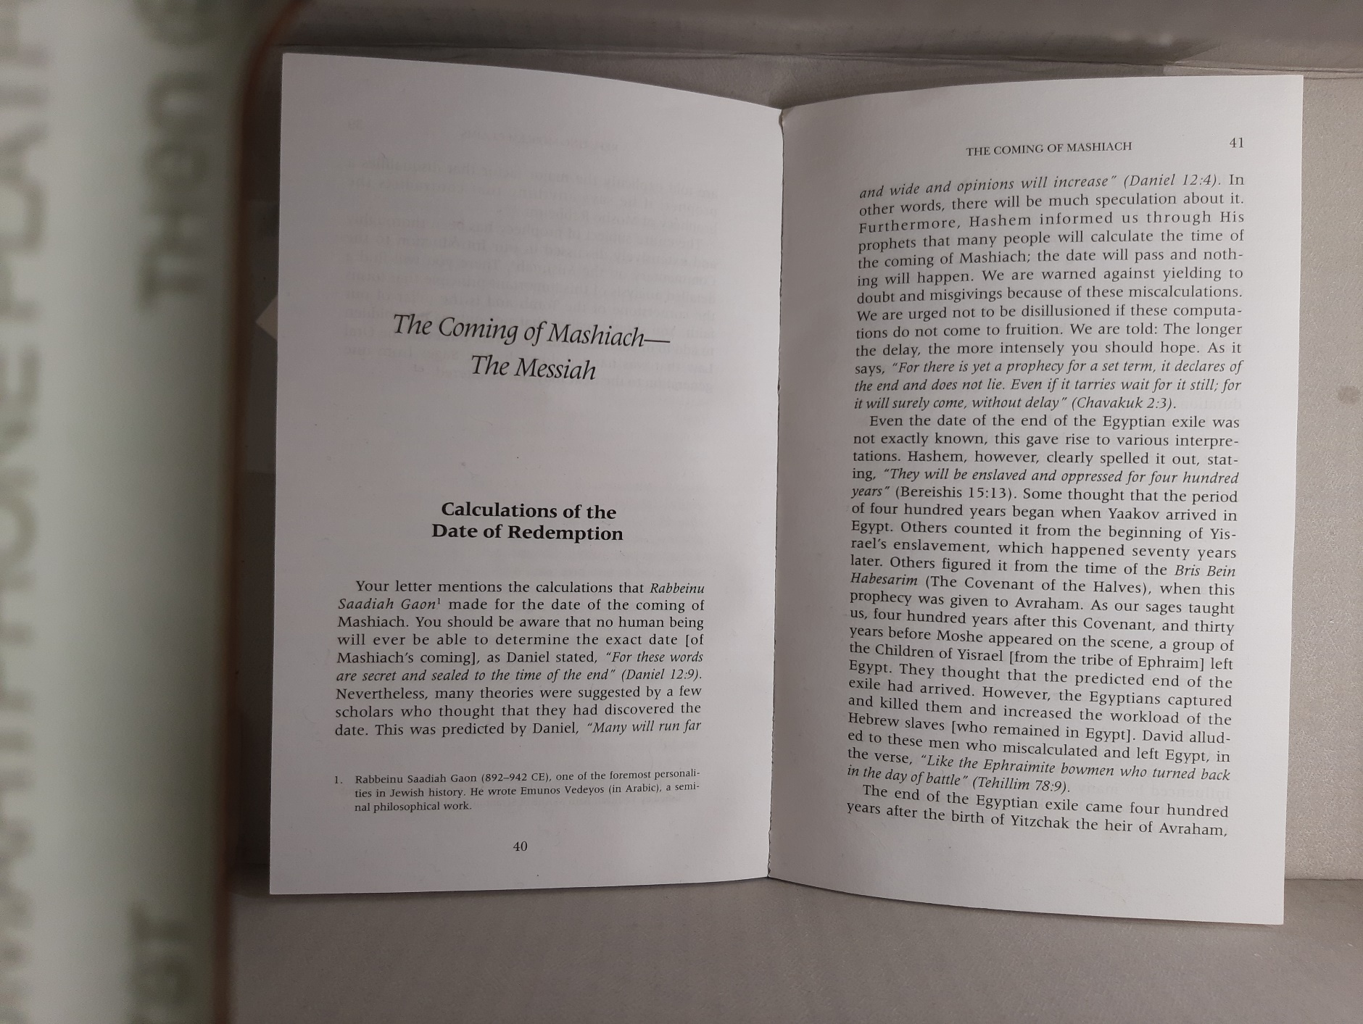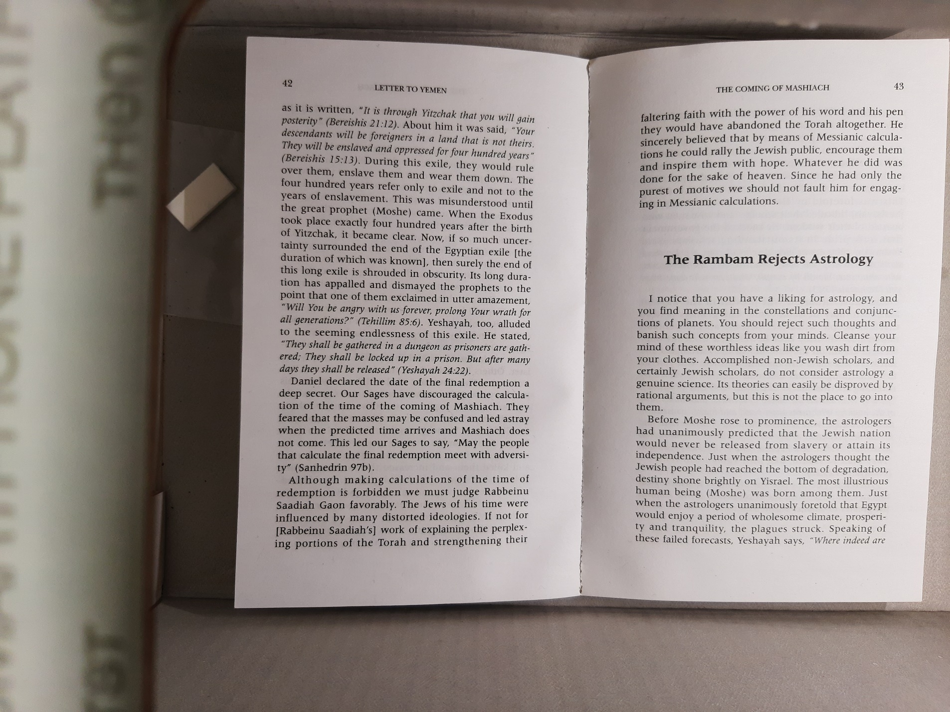

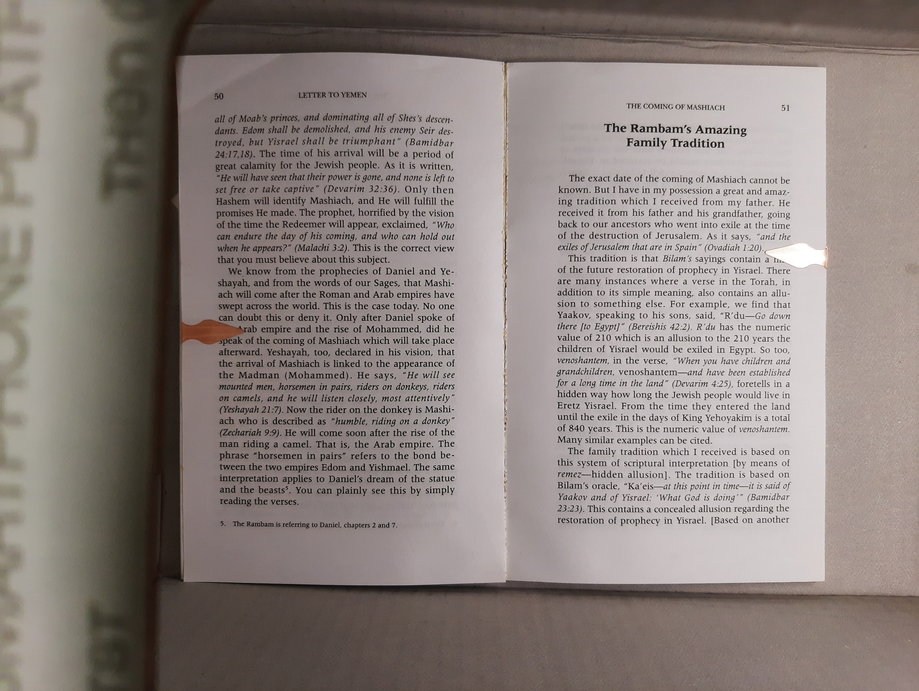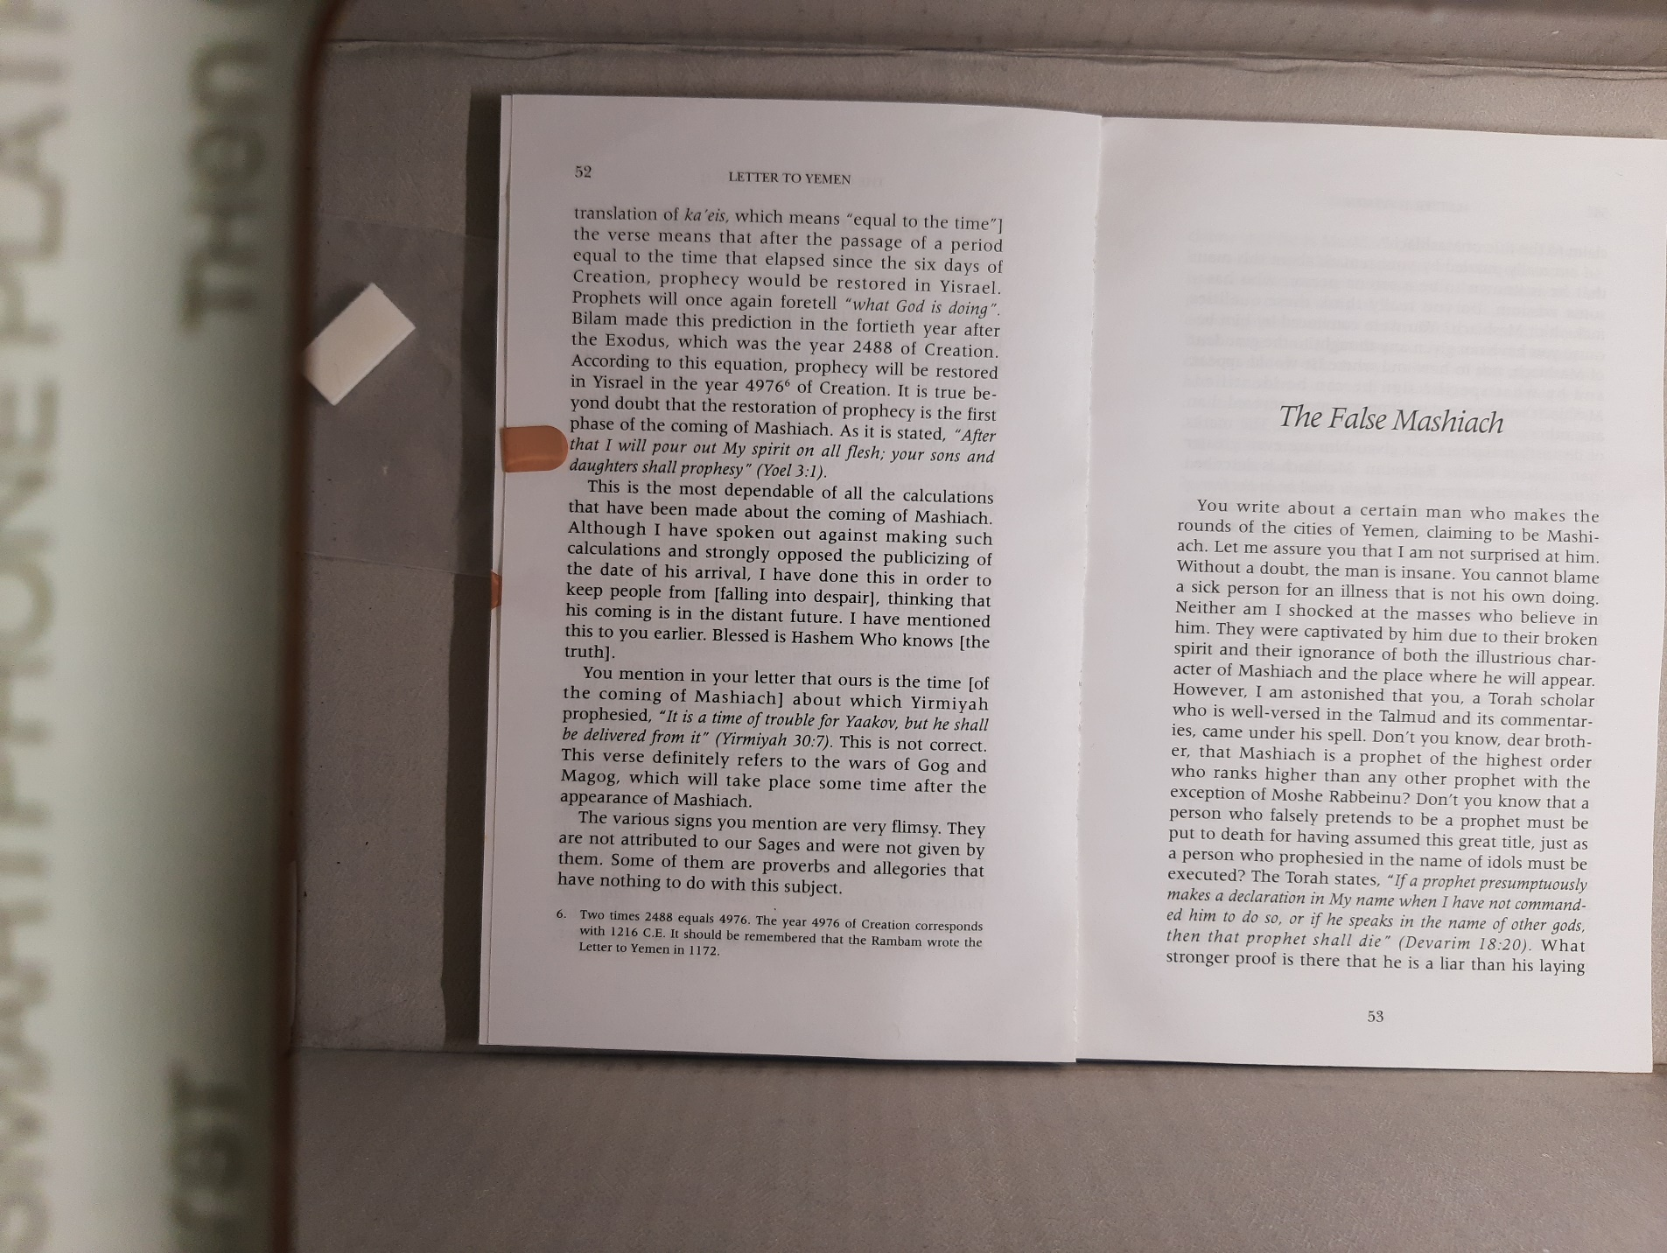

Why are we trying to understand - Torah
My grandfather’s joke (why we end the speeches with Mashiach)
To be continued …

Summary:
Daniel 7 – (fourth exile will have power over the Jews) a time, times and half a time
Daniel 8 – (service and Temple destroyed) for evening & morning, 2300
Daniel 12 – a time, times and half a time … 1290 days, 1335 days
Basic History Timeline
Yaakov Egypt –210 -- Redeemed and Torah – 40 – Israel – 440 – Beit Hamikdash built – 410 – Destroyed – 70 – Rebuilt – 350 – Calendar year 1 -- 70 – Destoyed – 1952 - Today

(notes: ce – common error; as years can be part of one year, calculations may be a few years off; (there was no year 0) most times are written near the times of those that write it)

R Eliezer Hagadol (first century) Zohar Bereishes brought by Abrabanel
Medrash of around nowish
R Chanina b Torisa - Rabbi Yochanan (Chanina) ben Torta said to him, Akiva! Grass will grow from your cheeks and still Mashiach will not have come.

Rabbi Saadiah Gaon (882-942)
- Daniel 7 – Yom Nakam bilibi

- Daniel 8 - Morning Evening means when the evening (hard times) of the Jewish people turn into morning.
- Alternatively Daniel 8 may be a reference to the Greek exile: Morning Evening means a cycle, a Jewish month – time that the Greeks ruled until the Chanukah miracle - ~ 2300/12.3683 = 185.9 ~180 years
- Alternatively this is referring to actual days, that Antiochus IV crushed the Jews and the Temple (see Ibn Ezra) – 2300/365.25 = 6 1/3 years

- There may be a connection between why the number of years chosen is 1290, as these are all of the basic offerings in a year
--------------
First Calculation:
2300 is from the first exodus [+ 40 Moshe + 850 Israel + 70 exile + 420 2nd Temple + remainder(920)] -> Temple destroyed year 70 = 988ce
We left Egypt 2448 + 2300 = 4748 -> 988ce

Rashi (1040-1105)
Is meant to be cryptic, and everyone has already given many explanations, and they were incorrect
- from a second calculation of Rabbi Saadiah Gaon
1 time is 480 (from the exodus till the Temple was built) + 410 (Temple) + half of both = ((480+410)/2=445) = 1335 from the time the Service was halted (~64) = 1399ce
Numerical value of הסתר אסתר = 1335 (and there is definitely a hint in that parsha)

- Morning & evening is a numerical value (fits 12th chapter and since the angel said this is a true time) - 574
574 + 2300 = 2874 from the first Exile, which is 1290 from the time that the service was halted (64ce) = 1354ce (+45 years) = 1399ce
[We were in Egypt 210year + 40 years of Moshe + 440 Israel pre Beit Hamikdash + 410 Beit Hamikdash + 70 Exile + 420 (-6 years of halted service) second Beit Hamikdash]

Medrash Rus Rabba 5 6
רַבִּי בֶּרֶכְיָה בְּשֵׁם רַבִּי לֵוִי כַּגּוֹאֵל הָרִאשׁוֹן כָּךְ גּוֹאֵל הָאַחֲרוֹן, מַה גּוֹאֵל הָרִאשׁוֹן נִגְלָה וְחָזַר וְנִכְסָה מֵהֶן, וְכַמָּה נִכְסָה מֵהֶן, שְׁלשָׁה חֳדָשִׁים, שֶׁנֶּאֱמַר (שמות ה, כ): וַיִּפְגְּעוּ אֶת משֶׁה וְאֶת אַהֲרֹן, אַף גּוֹאֵל אַחֲרוֹן נִגְלֶה לָהֶם וְחוֹזֵר וְנִכְסֶה מֵהֶם, וְכַמָּה נִכְסֶה מֵהֶם, רַבִּי תַּנְחוּמָא בְּשֵׁם רַבָּנָן אַרְבָּעִין וַחֲמִשָּׁה יוֹם, הֲדָא הוּא דִכְתִיב (דניאל יב, יא): וּמֵעֵת הוּסַר הַתָּמִיד וגו', וּכְתִיב (דניאל יב, יא): אַשְׁרֵי הַמְחַכֶּה וְיַגִּיעַ וגו'
Rabbi Berechya said in the name of Rabbi Levi: "like the first redeemer so is the second redeemer. How did the first redeemer reveal himself and then returned and was hidden from them? How long was he hidden? Three months, as it is said: "And they met Moses and Aaron (Exodus 5:20)". How does the latter redeemer reveal himself and then return and be hidden from them? How long is he hidden? Rabbi Tanchuma said in the name of the Rabbis: "45 days. See! It is written: And from the time that the continual burnt-offering shall be taken away (Daniel 12:11); and see! It is written: "Happy is he that waits, and comes (Daniel 12:12)".

Ibn Ezra (1089-1164)
- Daniel 8 is only referring to the Greek time when the Beis Hamikdash was shut down, and days means literally days, around 6+ years, and morning evening is meant to tell us that days means a day of evening and morning.
- All of the calculations are meant to be days specifically, and they are all referring to times of specific events

Daas Zekeinim (1100 -1300s Ki Savo 28 63)
והיה כאשר שש ה' עליכם להטיב אתכם ולהרבות אתכם. הוא אינו שש בפורענות אבל אחרים ששים ומפסוק זה נרמז הקץ שכתוב בדניאל ומעת הוסר התמיד ולתת שקוץ שומם ימים אלף מאתים ותשעים וה"ק והיה כאשר שש ה' עליכם להטיב אתכם במדבר ובארץ ישראל שהיתה שכינה עמכם ולהרבות אתכם במצרים שנאמר וירבו ויעצמו דהיינו אלף ומאתים ותשעים. ת' של גלות מצרים ות"פ מיציאת מצרים עד שנבנה הבית כדכתיב ויהי בשמונים וארבע מאות שנה לצאת בני ישראל מארץ מצרים ויבן את הבית לה'. ות"י שנה שעמד בית ראשון כמנין בזא"ת יבא אהרן הרי בין הכל אלף קק"צ כמו כן ימשך הגלות וזש"ה כי למועד מועדים וחצי וגו' תכלינה כל אלה. למועד הראשון מתפרש זמן כמו למועד הזה ומועדים וחצי ר"ל שני זמנים כמו מועד צאתך ממצרים כשני מועדים של מצרים וחצי ר"ל חצי השני מועדים דהיינו מועד שלישי והרי הן שלש מועדים כמו שעמדו במצרים כפי' הכתוב ומושב בני ישראל אשר ישבו במצרים שלשים וארבע מאות שנה. ושלשה פעמים ת"ל עולים אלף מאתים ותשעים ואז יכלה הגלות וכן אמר הכתוב האחר ויתיהבון בידיה עד עדן עדנים ופלג עדן ואי בעי הוי אמר בפירוש ג' מועדים אלא שרצה לסתום את דבריו וכאן רמז משה כן בתורה וכן אמר הושע וענתה שמה כימי נעוריה וכיום עלותה מארץ מצרים וענתה לשון מעון כמו וענה איים בארמנותיו כימי גלות נעוריה דהיינו גלות מצרים וכימי עלותה מארץ מצרים זהו מיציאת מצרים עד שחרב בית המקדש וזהו אלף מאתים ותשעים כדפריש לעיל ונמצא זה כתוב בתורה ושנוי בנביאים ומשולש בכתובים והקץ אחר דכתיב בסוף דניאל אשרי המחכה ויגיע לימים אלף שלש מאות שלשים וחמשה הוא נרמז בפ' אתם נצבים דכתיב ואנכי הסתר אסתיר פני מהם ביום ההוא וגו' הסת"ר אסתי"ר עולה בגימ' אלף שלש מאות שלשים וששה בעזר שדי אך משיח יבא כג"ה לסוף אלף קק"צ שהוא מ"ה שנים קודם אמנם אין אנו יודעים מהיכן מתחיל להמנין שנדע מתי יסיים. וכן מצינו בקץ מצרים שאמר הקב"ה וענו אותם ארבע מאות שנה וזה נאמר שלשים שנה קודם שנולד יצחק שהרי אברהם היה בן שבעים שנה באותו פרק ובן מאה היה כשנולד יצחק הרי שלשים שנה בין זה לזה. ושבט אפרים מנו ארבע מאות מברית בין הבתרים וטעו שלשים והרגום אנשי גת כדכתיב בדברי הימים ויש שהתחילו המנין משירדו למצרים וטעו ויש שמנו משהתחיל השעבוד וטעו והאמת היה שהארבע מאות שנה התחילו משנולד יצחק אך לא נודע על נכון עד שיצאו ממצרים. וכן על גלות בבל דאמר לו הקב"ה לירמיה לפי מלאת לבבל שבעים שנה וחשב בלשצר וטעה ומנה אחשורוש וטעה כמו שמפורש בפרק קמא דמגלה. כך קץ זה שמא מתחיל משנת ביטול התמיד בימי הורקנוס וארסתובלוס כדתניא בשלהי מסכ' סוטה תנו רבנן כשצרו מלכי בית חשמונאי זה על זה היה הורקנוס מבחוץ וארסתובלוס מבפנים וכו' ואז נתבטל התמיד וכשיבא משיח במהרה בימינו אז יתבררו ויתלבנו הדברים ואז נדע למפרע מהיכן התחיל. ואומר הרב בכור שור כי קץ זה נרמז באלפא ביתא של תשר"ק כי תשר"ק עולה אלף צפע"ס עולה שלש מאות ואז נמל"ך תוכן המלוכה לישראל כי כבר בא משיח י' שנים לסוף אלף קק"צ יטח"ז עולה ל"ד הרי תחלת שנת ל"ה וזהו אלף שלש מאות שלשים וחמשה. ואחר יטחז הד"ג ב"א התענוג בא שאז יכבש כל העולם תחת יד ישראל ר"ל הלויתן יבא לעשות סעודה לצדיקים:
Ramban (1194 – c. 1270)
Mistakes of previous generations are because Hashem wanted it to be cryptic – “But you, Daniel, keep the words secret, and seal the book until the time of the end. Many will range far and wide and the opinions will increase.”
- not cryptic, just not giving a starting point, so that there would not be despair.
- but we are nearing that time, so it is more clear to us (since the angel said to increase opinions, that shows that we can, and since we are close to the end, perhaps now the “hiding” will not be necessary, as it says the enlightened will understand, those close to the end.
- from destruction of Beit Hamikdash (70ce) until the beginning of the salvation, (the Mashiach b Yosef) will be 1290 = 1360ce /1358ce for 40 years he will gather in the Jewish people, and then for 5 Years the Moshiach will come and the era of peace will start 45 years later at 1403/1405ce
- Fortunate are those who wait – fortunate is that generation; for wait for the 45 years; those who wait will be given special mercy; each generation, as those that wait will be brought back
- Rome became the world power 206 years beforehand, + 1335 = 1540.
Hashem told Avraham that we will be in the Egypt golus and there will be 4 more exiles. We returned to Israel (dor reviei Yashuvu heina) 440 years. When asked about how long the fourth beast will rule over the Jews, we were told a time, times and half - 440*3.5 = 1540
(Perhaps there were multiple times)
- Evening, Morning 2300 – the evening (the exile) will be from the time of the Morning (first King from Yehuda (as we find in Bilaam’s prophecy)) will be 2300 years. – from David’s birth until Mashiach ben David starts his rule will be 2300 years = 1330 after the Destruction (earlier calculation) [David -70 + 410 first Beit Hamikdash + 70 exile + 420 second Beit Hamikdash + 1330 of fourth beast = 2300] +5 years when Mashiach starts = 1405ce
- Each vision added, and by the final words Daniel was able to enderstand everything, including when the times will start
- The Exile would equal the amount of time that we were in Israel and didn’t live there properly, 440 pre Beit Hamikdash + 410 Beit Hamikdash + 19 years when given permission + 420 second Beis Hamikdash = 1290 years since the destruction = 1360ce. Medrash Eicha Admaschem linegdichem zarim ochlim osah – they will be the same amount of time. The extra 45 years correspond to the 40 years of Moshe and the 5 years for prep mentioned in Yechezkial 39.
- many other verses numerically equal this time, such as bitzar licha
- end of notes have entire Ramban Sefer Hageula ch4 and Barcelona Disputation of these verses

Rabbeinu Bachya (1255–1340) on Bereshit 12:13
1360 ce
Our sages (Nedarim 32) claim that the exile in Egypt was due to Avram asking G-d in 15,8 “how will I be sure that I (my descendants) will inherit the land?” This is also what we find in Pirke d'Rabbi Eliezer 48 where G-d is quoted as having told Avram of this exile in reply to his question. [I suppose the version in Pirke d'Rabbi Eliezer is older than the version in Nedarim. Ed.] At any rate, it is clear that Avram’s query in that chapter was considered sinful. The common denominator of the views expressed by our sages is that the sin consisted of thoughts which Avram articulated The result was 430 years of exile of varying degrees of severity. Seeing that the exile was due to a sin it was divided into three stages. The sin consisted of three parts. 1) sinful thought; 2) sinful speech; 3) sinful action. This is why the intelligent reader ought to reflect that the present exile is likely to last three times as if the exile in Egypt lasted 430 years and it was due merely to Avram’s inadvertently sinful utterance, it stands to reason that the present exile will last three times as long. After all, the sin which led to the 430 years of exile in Egypt was confined to an utterance by Avram which G-d considered sinful. The sin which led to the destruction of the first Temple, idolatry, (Yuma 9) was certainly much worse and not committed inadvertently and only by an ancestor to whom the Torah had not yet been given. At the time when the First Temple was destroyed most of the people had been guilty of sinning in thought, in speech, as well as in deed. G-d had therefore decreed three times 430 years of exile on the Jewish people. This must have been the basis of Daniel’s calculation. When you examine the final verses in Daniel 12,11 in which he mentions 1290 years, and 12,12 אשרי המחכה ויגיע לימים אלף שלש מאות שלשים וחמשה in which he speaks about the redemption at the end of 1290 years (years), this number is made up of three times the number 430. This may also have been what the prophet Micah 7,20 alluded to when he said: תתן אמת ליעקב חסד לאברהם,”You will keep faith with Yaakov, and maintain your love for Avraham.” (The word אמת is understood as an acrostic of אלף מתים תשעים) This was a prayer for G-d to hasten the redemption. He appealed to G-d who had sworn that He would invoke the attribute of חסד when it comes to the redemption of Israel as we know from Deut. 32,40 where G-d swore an oath to avenge Israel from its enemies. The words there כי אשא אל שמים ידי, “I raise My hand to heaven (in an oath)” are paraphrased by Daniel 12,7 וישבע בחי העולם, “He swore an oath in the name of the Eternal.”

Ralbag (1288 – 1344)
- Time, times and half -> 419.5 (first Temple) + 437.5 (second Temple) + ½ - 428.5 = 1285.5 (+70 from Temple Destruction) = 1355ce the power will be removed, 1335 will be destroyed 1405ce
- Evening from morning is referring to when Shmuel became the leader, and 2300 years afterwards
- …

Abarbanel 1505 (has a few numbers, bring all of them)

Explains Gemara in Sanhedrin as 440ce -??

Malbim (1809 – 1879)
- Everyone assumes that a half is half a time, while it could be half of the whole time
- possibility of 2 times: 400 years of Egyptian exile or 410 years Beit Hamikdash
- if 400, then 400*3= 1200 + 1200*.5 = 1800 destruction at year 70 = 1868 (doesn’t match any of the other numbers)
----
- if 410, then 410*3=1230 + 1230*.5 = 1845 -> 1913ce (end of the 4th beast)
- 2300 from the time of the Vision is 1928ce (Yerushalmi there will be 14 years process)
The years of 1290 and 1335 are two cumulative times. The first are not the times for Mashiach, the second are when “Mashiach is knocking” These times are from the “removal of the Tamid” which can either mean second Beis Hamikdash, but that is after end of the 6000 years, so no, or first destruction, but that doesn’t match the “placing of the abomination”, so also no. Could be Menashe, Achaz or Amtalliah. Logic dictates the first time, so add to that 1290 you get…
First time of 1290 was in 590ce (there was an attempt to rebuild the Beit Hamikdash, which they paid the Romans a lot of money, and it collapsed 3 years in a row to unnatural events (although that was in 361) (might have mistaken my calculations)) add to that the 1335 is 1925ce for the Beit Hamikdash to start being built, 1928 for it to be completed
- Zohar every 60 years there is a heavenly push for Moshiach
-----
Alternately
We will go back to the time being 400 years each which gives us
The times may not match because they are for a few subsequent times:
1868 will be the time that the two “angels on the shore” will be removed
1878 will be the time where the 2300 from the first destruction, when the world will acknowledge the Jewish people/faith
Techiyas Hameisim 2203ce, which is the two times from the first destruction

Chofetz Chayim (1838 – September 15, 1933)
1938


Perhaps there is a correlation of times and Hikeisi es Kol Haaretz Cherem
- My thought that the only reason why 400 was counted from Yitzchak was born, was because the Avos never complained

------------------
Talmud R Simlai (~300s)
האכלתם לחם דמעה ותשקמו בדמעות שליש
You have fed them with the bread of tears and have given them tears to drink in great measure [shalish]
- +70) * 3 = 1410
- First Beit Hamikdash destroyed 420bce - 988
- (from second temple - 1480)
- (also, see Maharsha)

Talmud R Akiva (~50-135)
עוד אחת מעט היא ואני מרעיש את השמים ואת הארץ
There will be one more (exile), but it will be short, and I will storm up the heavens and the earth. (Maharsha)
~100-200s
Talmud in Avodah Zara Rabbi Chanina - ~470ce

Rambam (1138–1204, written 1172)
כִּי לֹא־נַחַשׁ בְּיַעֲקֹב וְלֹא־קֶסֶם בְּיִשְׂרָאֵל כָּעֵת יֵאָמֵר לְיַעֲקֹב וּלְיִשְׂרָאֵל מַה־פָּעַל אֵל
For there is no clairvoyance in Yaakov and no divining in Yisrael, therefore there will be a time / like this time, they will ask fo Yaakov and Yisroel, “What is the Almighty’s plans”
Stated in the year 2448.
The next 2448 will be 4976 – year 1216

https://www.koltorah.org/halachah/sefer-daniel-and-predicting-mashiachs-eta-by-rabbi-chaim-jachter
